Dominic Drury

09/14/2024

CS-470

2-3 Assignment: Docker Compose and Orchestration

docker-compose images command output

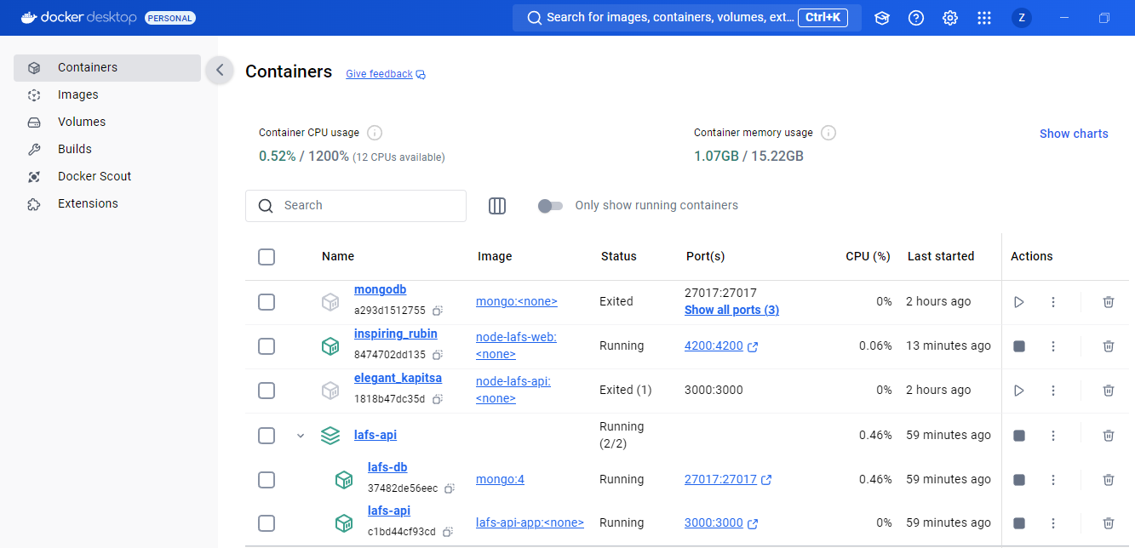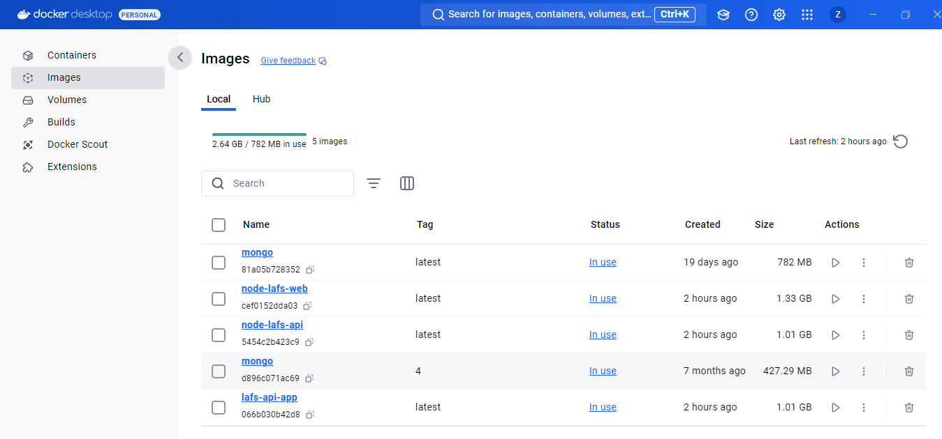

LoopBack explorer frontend running in the container, adding a new question

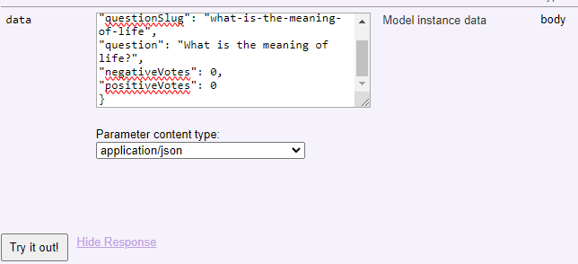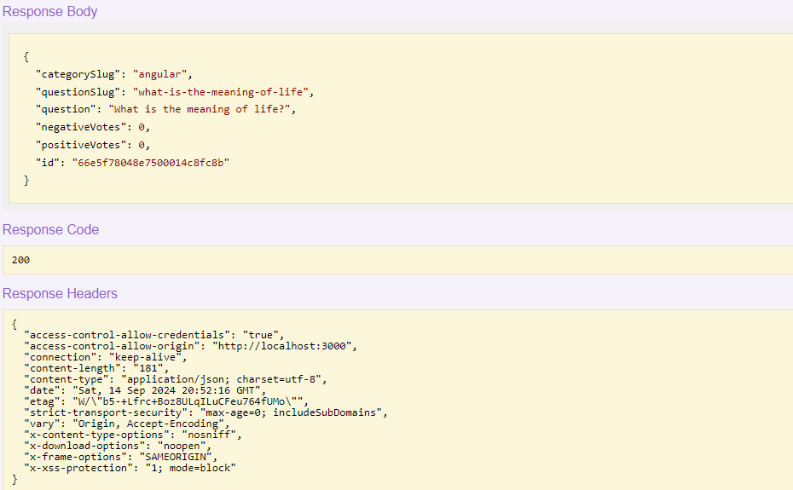

Angular frontend running in the container, showing the previously entered question

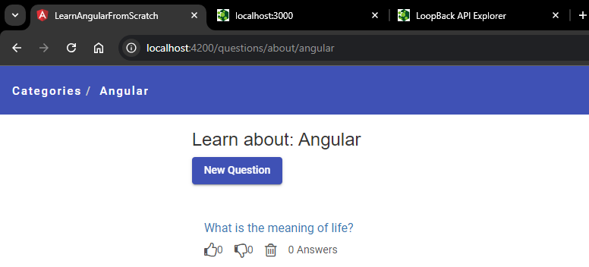

MongoDB showing question collection

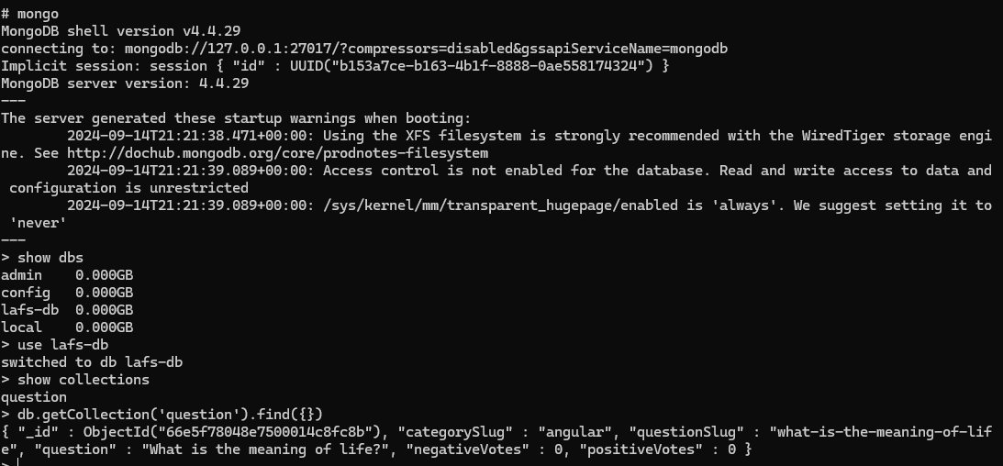

Docker ps -a (output)

